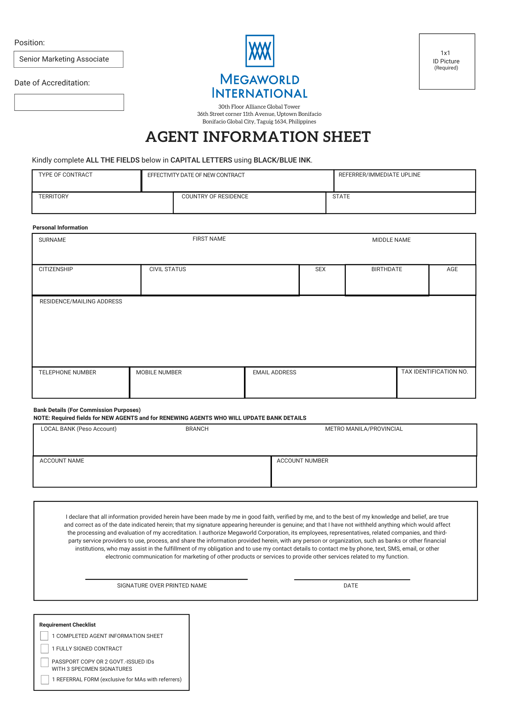
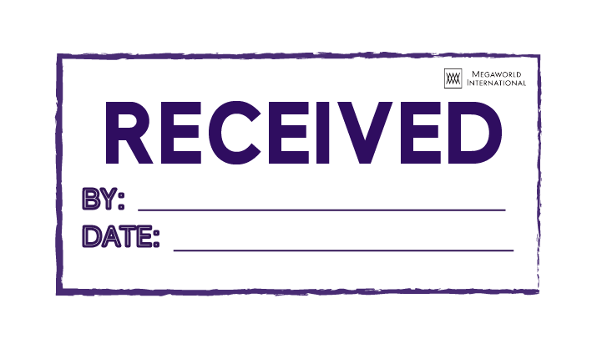
{{insert_image photo 96 96}}
Business Development Group
{{format_date _date “MMMM DD, YYYY”}}

{{format_date ADate “MMMM DD, YYYY”}}

{{contract}}
{{format_date ADate “MMMM DD, YYYY”}} – {{format_date ADate “MMMM DD, YYYY” “en” “+4months”}}
{{marketingmanager}}
{{age}}
{{tin}}

{{state}}
{{territory}}
{{country}}

{{middlename}}
{{surname}}
{{firstname}}

{{civilstatus}}
{{citizenship}}
{{sex}}
{{birthday}}

{{address}}

{{telephone}}
{{mobile}}
{{email}}

{{localbank}}

{{bankacctname}}
{{bankacctnumber}}

{{insert_image signature 200 70}}

{{firstname}} {{middlename}} {{surname}}
{{format_date ADate “MMMM DD, YYYY”}}



SALES AGENCY AGREEMENT (SAA)
Senior Marketing Associate (Sr. MA)
{{insert_image signature 200 70}}
{{format_date ADate “MMMM DD, YYYY”}}
Date: _________________________________
{{firstname}} {{middlename}} {{surname}}
Dear _____________________________________, (Complete Name of Senior Marketing Associate)

We are pleased to execute a (4) four-month agency agreement with you in connection with the sales of our projects. During the period of this agreement, you are authorized to represent yourself as a Senior Marketing Associate of the International Marketing Division of Megaworld Corporation.

The following terms and conditions shall govern our agreement:

- Term : 4 months

- Project Listing : For the list of projects, please click
here: Annex A

- Commission : You shall be entitled to commission
rates as specified in Annex B.

Such commission is payable according to existing company sales policies as specified in Annex C.

Commission will be in Philippine Peso and will be deposited to your submitted Philippine Peso account as reflected on the Agent Information Sheet.

- Payments : Payments should be deposited by the
client directly to the developer’s account as specified in the Bank Account Details to view click here:
Annex D.

- Quota : You are required to produce a
minimum personal sales volume of TEN MILLION PESOS (P10,000,000.00) in four (4) consecutive months.

- Documentary Requirements : Scanned passport copy or one (1)
valid government-issued ID; three (3) specimen signatures on a separate sheet of paper; and 1x1 ID Picture


- Notwithstanding the four-month term as provided herein, it is hereby agreed that this agreement may be sooner or later terminated by the company for causes such as violation of any company policies, rules and procedures, or failure to meet the requirements during the prescribed 4-month term.

- Conversely, this agreement may be renewed based on your satisfactory performance as reviewed by the company during the term or by your mutual agreement.

- During the term of this agreement, you shall abide by the Code of Ethics (Please refer to Annex E) and all the rules, regulations, policies, and decisions of the management, specifically on, but not limited to, settlement of sales conflicts and action taken on the results of your semiannual evaluation.
{{insert_image signature 200 70}}
- Confidentiality. You acknowledge that, in the course of your services under this Agreement, you may be allowed to access to an/or be in possession of Confidential Information of the Company. Accordingly, you expressly agree that such access or possession of Confidential Information is allowed exclusively for the limited purpose of performing your duties and functions. You undertake not to divulge or use such Confidential Information, in any manner, outside of the above-enumerated duties and functions in this Agreement. In case of violation or threatened violation of this clause, you expressly agree that the Company is entitled to immediately terminate this Agreement and/or secure an injunction against you and/or your violation of this provision, in addition to securing payment of such actual damages as the Company may have suffered or incurred.

- SENIOR MARKETING ASSOCIATE (Sr. MA)

Qualification for the Position
Marketing Associates who shall sell at least 3 units or Php15M, whichever comes first, WITHIN one contract period are eligible to be promoted as Senior Marketing Associate (Sr.MA) immediately.

Retention of Status
Senior Marketing Associates shall be evaluated every end of contract period from date of accreditation or promotion and shall produce a minimum of (2) two sales or Php10M, whichever is applicable, to maintain the Sr. MA post.

Policy on Inactivity
A Senior Marketing Associate who fails to generate the required minimum sale after the contract period shall be reverted to a Marketing Associate post. The policy on inactivity for MAs apply thereafter.

- COMMISSION

- Megaworld International will deposit commission check/s to the bank account specified in this contract.
- Kindly provide the correct bank account details and ensure that it is active.
- Commission team must be notified for any changes, dormant or closed account.
- For provincial branches, applicable bank charges may apply.
- Commissions will be in Philippine Pesos (PHP) and are subject to Philippine Expanded Withholding Tax. Ten percent (10%) for individual payee and fifteen percent (15%) for non-individual (company name).
- Commission computation is based on the Net Contract Price.
- Commissions will only be processed upon approval of the buyer's reservation documents, paid the required payment milestone and submission of a complete set of accreditation papers.
- Released commissions shall be retrieved for back-out accounts

We look forward to a mutually beneficial relationship with you.
{{insert_image signature 200 70}}

Signed and Accepted by:
{{territoryhead}}
{{firstname}} {{middlename}} {{surname}}
___________________________________ ___________________________________
(Signature over Printed Name) (Signature over Printed Name)
Territory Head Senior Marketing Associate

Witnessed by:

{{countrymanager}}
{{marketingmanager}}
___________________________________ ___________________________________
(Signature over Printed Name) (Signature over Printed Name)
Country Manager Marketing Manager

{{seniorcountrymanager}}
{{marketingdirector}}
___________________________________ ___________________________________
(Signature over Printed Name) (Signature over Printed Name)
Sr. Country Manager Marketing Director
{{vicepresident}}
{{asst.countrymanager}}
__________________________________ ____________________________________
(Signature over Printed Name) (Signature over Printed Name) Asst. Vice President/Vice President Asst. Country Manager

Annex E
- CODE OF ETHICS

The Code of Ethics serves as our guide in our working relationship with our business partners: Megaworld VP-Sales, AVP, Senior Country Managers, Country Managers, Assistant Country Managers, Marketing Directors, Marketing Managers, and Marketing Associates/Senior Marketing Associates.

We agree to support Megaworld International's sales policies, programs, regulations and procedures as our guide in the professional conduct of our business.

We will properly inform our respective network of marketing agents about the Company's policies, programs, regulations and procedures to protect their rights and privileges as business partners.

We will encourage our marketing agents to strive for promotion to higher levels of position in the Company for personal and professional growth and development.

We will respect the marketing network of our fellow marketing agents by:

- Not recruiting marketing agents from other groups to join one's own group in Megaworld International, and/or one's group in other real estate companies or any direct selling company;
- Not selling to marketing agents from other groups;
- Encouraging dissatisfied marketing agents from other groups to settle their differences with their current superiors to avoid transfer of sponsorship.

We will refrain from conducting other real estate marketing business within Megaworld International's premises and/or during Company-sponsored activities. Likewise, we will refrain from using Company resources for other real estate marketing businesses or any other business.

We shall not engage in selling products directly or indirectly competing with Megaworld International.

Together, we agree to police our respective marketing network to protect the rights and privileges of our fellow marketing agents.

Megaworld International reserves the right to disqualify and/or terminate any Marketing agent (VP-Sales, AVP, Senior Country Managers, Country Managers, Assistant Country Managers, Marketing Directors, Marketing Managers, Marketing Associates/ Senior Marketing Associates).
{{insert_image signature 200 70}}
from doing business with the company for failure to comply with these policies and for other reasons whatsoever that will prejudice the company's operations as a whole.
{{firstname}} {{middlename}} {{surname}}
{{format_date ADate “MMMM DD, YYYY”}}
_______________________________ ____________________________
(Signature over Printed Name) Date
Senior Marketing Associate

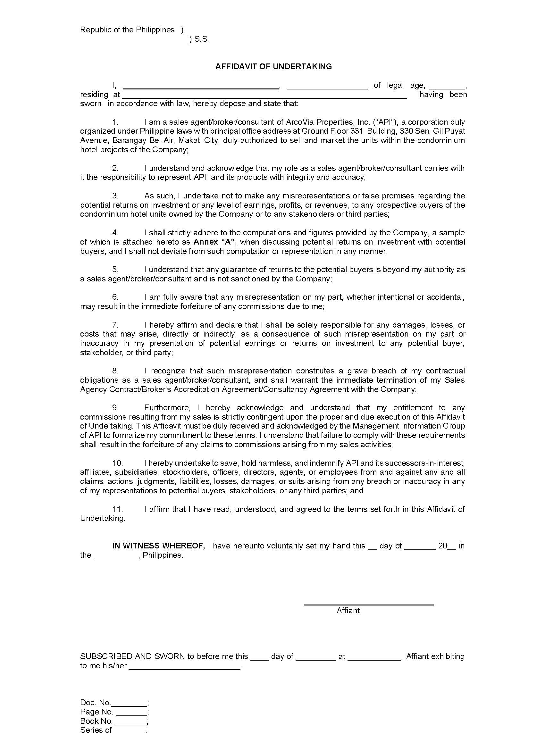
{{address}}
{{citizenship}}
{{firstname}} {{middlename}} {{surname}}
{{age}}

Annex “A”

{{insert_image signature 200 70}}

{{firstname}} {{middlename}} {{surname}}

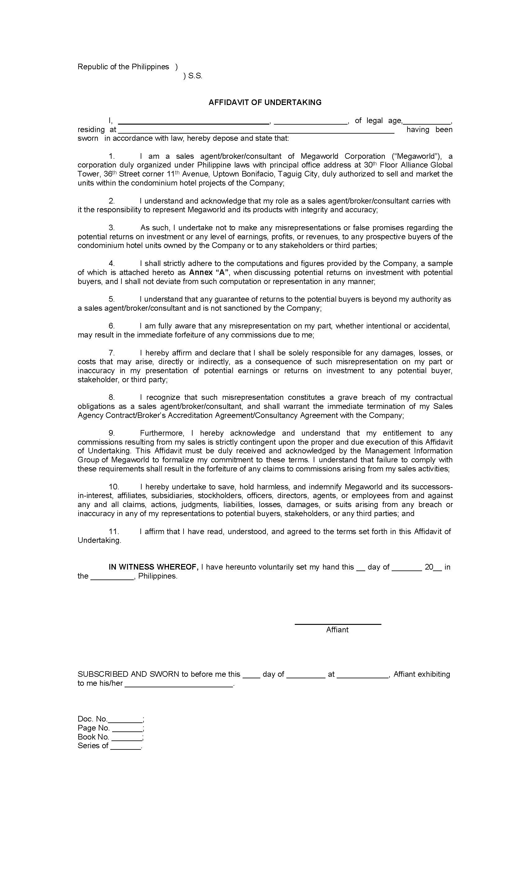
{{firstname}} {{middlename}} {{surname}}
{{age}}
{{citizenship}}
{{firstname}} {{middlename}} {{surname}}
{{address}}
{{insert_image signature 200 70}}
Annex “A”
{{insert_image signature 200 70}}
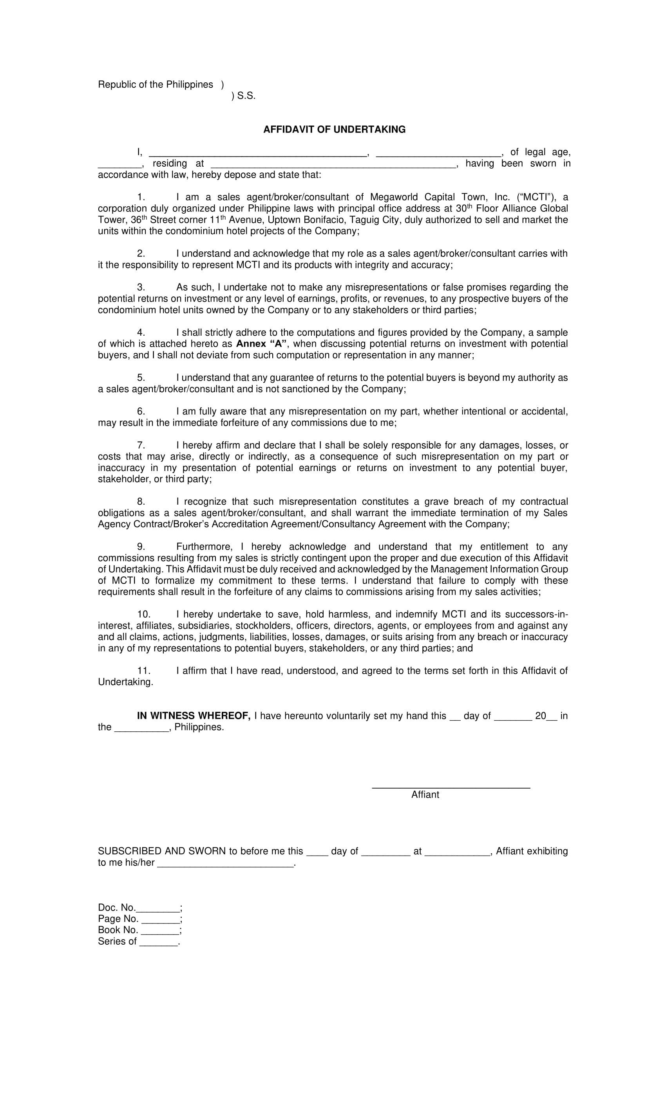
{{firstname}} {{middlename}} {{surname}}
{{citizenship}}
{{age}}
{{address}}

Annex “A”

{{insert_image signature 200 70}}

{{firstname}} {{middlename}} {{surname}}

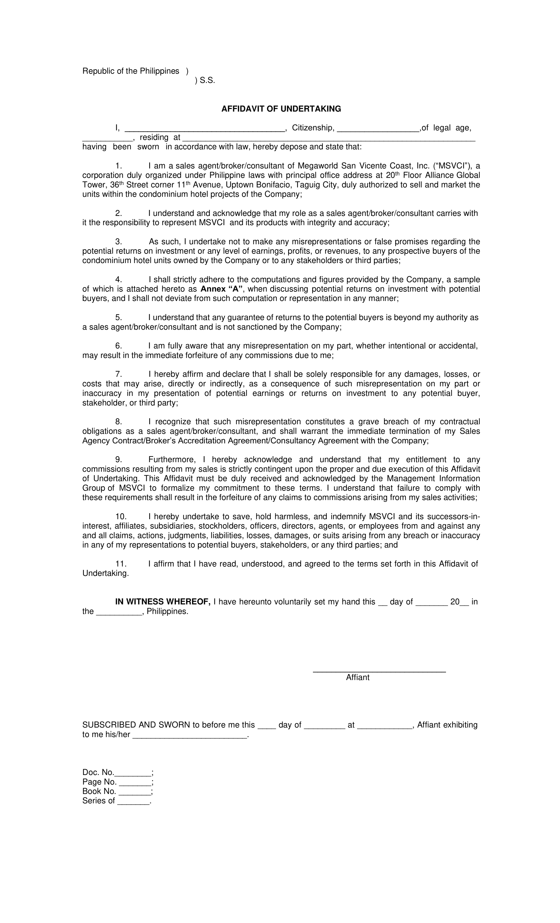
{{citizenship}}
{{firstname}} {{middlename}} {{surname}}
{{address}}
{{age}}

Annex “A”

{{insert_image signature 200 70}}

{{firstname}} {{middlename}} {{surname}}

{{insert_image ID2 192 288}}

{{insert_image signature 200 70}}

{{insert_image signature 200 70}}

{{insert_image signature 200 70}}

{{insert_image passport 384 768}}

